TraIT Proteomics QC Tool – Software for Monitoring LC-MS Performance
Netherlands Bioinformatics Centre, Proteomics Task Force, Geert Grooteplein 28, 6525 GA Nijmegen, The Netherlands.
OncoProteomics Laboratory, VU University Medical Center–Cancer Center Amsterdam, De Boelelaan 1117, 1081 HV Amsterdam, The Netherlands.

Colophon
Date | Version | Changes | Author(s)
22 Jan 2013 | 0.1 | Initial version | Pravin Pawar, Marcel Kempenaar
25 Jan 2013 | 0.2 | Added content to Part 2: User guide | Pravin Pawar, Marcel Kempenaar
17 Feb 2013 | 0.3 | Received feedback and comments from Thang | Pravin Pawar, Thang V Pham
27 Feb 2013 | 0.4 | Received contribution from Marcel | Pravin Pawar, Marcel Kempenaar
06 Mar 2013 | 0.6 | Processed comments from version 0.3 and 0.4 | Pravin Pawar
10 Mar 2013 | 0.8 | Started with MSQC Report Viewer User Manual | Pravin Pawar
18 Mar 2013 | 0.9 | Completed MSQC Report Viewer User Manual | Pravin Pawar
18 June 2013 | 0.94 | Updating user manual according to QC-Full version | Pravin Pawar
25 June 2013 | 0.95 | Updated repository homepage, added instructions for configuring NIST components and spectral library | Pravin Pawar
03 July 2013 | 0.96 | Processed feedback and comments from Thang | Pravin Pawar, Thang V Pham
20 August 2013 | 0.97 | Processing feedback of the BioAssist programmer’s meeting on 12 July. | Pravin Pawar

Table of Contents
TraIT Proteomics QC Tool – Software for Monitoring LC-MS Performance 1
Table of Contents 2
TraIT Proteomics QC Tool 3
Description 3
System requirements and dependencies 3
Download and Installation Procedure 3
Running the QC pipeline 5
Running the QC Report Viewer 6
Known issues and troubleshooting 6
Description of QC Pipeline Output 7
Description of QC Report Viewer Output 11
References 15
Appendix 1 – QC-Full Performance Metrics – Description, Significance and Examples 17

TraIT Proteomics QC Tool

Description
Proteomics deals with the large-scale study of proteins and has become a powerful technology in discovery of drug targets and biomarkers. Modern day proteomics is largely based on nano-liquid chromatography coupled to high-resolution tandem mass spectrometry (nanoLC-MS/MS). However, the reproducibility of MS results is considered by many as insufficient. In part, inadequate quality control (QC) might be responsible for the lack of reproducibility [1]. The importance of well-established QC has become a focal point in the field of proteomics [2]. The National Institute of Standards (NIST) has developed a QC pipeline for evaluating analytical performance of a common discovery-based proteomics platform by monitoring selected output from a LC-MS/MS system. This pipeline is known as NIST MSQC Pipeline [3]. The 46 QC metrics for monitoring chromatographic performance, electrospray source stability, MS1 and MS2 signals, dynamic sampling of ions for MS/MS, and peptide identification are described in [4]. Application of these metrics enables rational, quantitative quality assessment for proteomics and other LC-MS/MS analytical applications.
As part of the CTMM TraIT project [5], the Netherlands Bioinformatics Institute (NBIC) and OncoProteomics Laboratory (OPL) have adapted the NIST MSQC Pipeline and developed QC Report Viewer tool to suit the proteomics QC requirements of the OPL lab. The adapted pipeline is named as Proteomics QC Pipeline. Compared to the NIST MSQC Pipeline, the adapted version triggers pipeline processing on the availability of a new RAW data file in a fully automatic fashion– and creates a QC report combining the NIST metrics with a number of custom metrics. The Proteomics QC Report Viewer aggregates and shows all available QC reports from the QC pipeline report directory. It includes functionality of sorting, filtering, zooming and comparing these reports as per the need of proteomics researchers. Together, the QC Pipeline and QC Report Viewer are named as TraIT Proteomics QC Tool.

System requirements and dependencies
The TraIT Proteomics QC Tool is primarily designed and tested for use on the Microsoft Windows platform. The system requirements and dependencies for installing and using the tool are listed in Table 1.
Table 1: System requirements and dependencies

Dependencies | Link | Explanation
ActivePerl | http://www.activestate.com/activeperl | The pipeline consists of NIST scripts written in Perl language.
JDK | http://www.oracle.com/technetwork/java/javase/downloads/index.html | Part of the pipeline is developed using Java as a programming language. JVM is required to run programs written in Java.
Maven | http://maven.apache.org/ | Maven is used in the QC Report Viewer to build the project and create executable JAR file.
Python > 2.6 | http://www.python.org/getit/windows/ | The pipeline consists of NBIC scripts written in Python.
robocopy | Standard available in Windows (> XP) | Data copy from acquisition system
Xcalibur or Thermo MSFilereader | http://sjsupport.thermofinnigan.com/public/detail.asp?id=703 | Provides libraries for converting RAW files

Download and Installation Procedure
The installation procedure requires that the system requirements are followed and all the dependencies are installed.
Project repository homepage: https://github.com/CTMM-TraIT/trait_proteomics_qc_tool/
Step 1: To download project files, click on the ‘Download ZIP’ button accompanying above homepage. This will download file trait_proteomics_qc_tool-master.zip on your computer.
Step 2: Create <installation_folder> on your computer and unzip trait_proteomics_qc_tool-master.zip into <installation_folder>. This will create trait_proteomics_qc_tool-master folder along with two sub-folders: ProteomicsQCPipeline and ProteomicsQCReportViewer. The folder ProteomicsQCPipeline contains source code and binaries for the Proteomics QC Pipeline. The folder ProteomicsQCReportViewer contains source code and binaries for the Proteomics QC Report Viewer.
Step 3: To download NIST MSQC Pipeline components of the pipeline, open the following webpage:
http://peptide.nist.gov/software/nist_msqc_pipeline/NIST_MSQC_Pipeline.html
Click on the Download link in the Installation Instructions section. Download the file NISTMSQCv1_2_0_x64.zip. Unzipping this file will create folder NISTMSQCv1_2_0.
Disclaimer: It is preferred to contact NIST in case the NIST MSQC version 1.2.0 does not satisfy your requirements.
Step 4: Place NISTMSQCv1_2_0 folder in the trait_proteomics_qc_tool-master /ProteomicsQCPipeline/QC directory.
Note: (On server 10.13.1.103, use NISTMSQCv1_5_0 located in folder C:\qc-data\QCArchive27Feb\archive\QC)
Step 5: Adjust location settings in 'ProteomicsQCPipeline/QC/run_msqc_pipeline.py'
- _REPORT_DIR is the absolute location where QC reports will be stored. Replace <installation_folder> part from the following line with its absolute value.
_REPORT_DIR = <installation_folder>/trait_proteomics_qc_tool-master/ ProteomicsQCPipeline/Reports
- _QC_HOME pointing to the absolute location of the 'QC' folder. Replace <installation_folder> part from the following line with its absolute value.
_QC_HOME = <installation_folder>/trait_proteomics_qc_tool-master/ ProteomicsQCPipeline/QC
Step 6: The QC pipeline is pre-configured and tested with SpectraST search engine.
- In order to configure spectral library named Jurkat28_0.8m for use with SpectraST search engine: Add Jurkat28_0.8m.pepidx, Jurkat28_0.8m.spidx, Jurkat28_0.8m.splib, Jurkat28_0.8m.sptxt files in folder ProteomicsQCPipeline /QC/NISTMSQCv1_5_0/libs. Also, create empty Fasta file Jurkat28_0.8m.fasta in the libs directory.
- Change nist_library property in the script QC\run_msqc_pipeline.py (line No. 275) as follows:
####nist_library = 'Jurkat28_0.8m' -> where #### are four white spaces.

Step 7: Configure properties in file ProteomicsQCReportViewer/appProperties as follows:
Table 2: Configurable properties in the Proteomics QC Report Viewer appProperties file

Property name and description | Default Value | Acceptable Values
RootFolder  (folder containing QC pipeline output reports) | ..\\..\\ProteomicsQCpipeline\\Reports | The folder containing QC pipeline output reports. The reports directory has following three levels:  1. Year <YYYY>: e.g. 2013  2. Month <MMM>: e.g. Mar  3. Report folder for individual RAW file
ShowReportsFromDate  (The date from which to show reports) | <none> | <none> represents empty string. In this case reports from previous two weeks (14 days) are shown. Acceptable format for the date is DD/MM/YYYY. E.g. 13/03/2013
ShowReportsTillDate (The date till which to show reports) | <none> | <none> represents empty string. In this case today’s date is assigned for including reports to show. Acceptable format for the date is DD/MM/YYYY. E.g. 13/03/2013

Running the QC pipeline
The Proteomics QC pipeline is designed to operate in two modes: The offline-processing mode assumes availability of MS RAW data files in a particular directory. The online processing mode is used to run QC pipeline immediately after RAW data file is generated by LC-MS/MS method. The installation of robocopy is necessary – to copy newly generated RAW data file to pipeline RAW files directory.
Furthermore, the pipeline requires sufficient disk space – for copying RAW data file and storing intermediate data files. It is recommended to make sure that there is >25 GB disk space available at any time during the pipeline run.

Offline processing mode
For processing existing files in a directory, start QC pipeline with:
- cd <_QC_HOME> where _QC_HOME is the absolute location of the 'QC' folder.
- 'python robocopy_monitor.py <input_folder> <output_folder>' where:
  - <input_folder> contains the RAW files to process.
  - <output_folder> is used to store intermediate data files.

Online processing mode
For real-time processing of files copied by Robocopy, start with:
- cd <_QC_HOME> where _QC_HOME is the absolute location of the 'QC' folder.
- 'python robocopy_monitor.py <input_folder> <output_folder> <copylog_folder>' where:
  - <input_folder> contains the RAW files to process.
  - <output_folder> is used to store intermediate data files.
  - <copylog_folder> points to the location where Robocopy writes a logfile.

Help message
cd <_QC_HOME> where _QC_HOME is the absolute location of the 'QC' folder.
- Run 'python robocopy_monitor.py -h' to see the help message.

Running the QC Report Viewer
It is required to download and install Apache Maven 3.1.0 to build and run the QC Report Viewer. Refer to the following link for Maven download and installation:
http://maven.apache.org/download.cgi
After configuring Maven in your computer, open command prompt and run following commands to run the Report Viewer:
- cd <ProteomicsQCReportViewer> where <ProteomicsQCReportViewer> is the absolute location of the 'ProteomicsQCReportViewer' folder.
- ProteomicsQCReportViewer>mvn -Dmaven.test.skip=true package
  - This command is used to compile source code and package it in a executable jar file ProteomicsQCReportViewer-1.6.5.jar in directory target.
- ProteomicsQCReportViewer>cd target
- ProteomicsQCReportViewer/target>java –jar ProteomicsQCReportViewer-1.6.5.jar

Known issues and troubleshooting
Table 3: Known issues and troubleshooting

Issue | Pipeline Output | Troubleshooting
Python module win32serviceutil is not installed. | ImportError: No module named win32serviceutil | Download and install pywin32-214.win32-py2.7.exe from  http://sourceforge.net/projects/pywin32/?source=dlp
Python module watchdog.observers is not installed | ImportError: No module named watchdog.observers | Install watchdog package as per the following command line operations:  cd <python_dir\Scripts> e.g. <c:\Python27\Scripts>  c:\Python27\Scripts>easy_install watchdog
Access denied to folder <_REPORT_DIR> while writing QC report. | WindowsError: [Error 5] Access is denied: ‘C\\:TrialOfTraitProteomicsQCTool\\ProteomicsQCPipeline\\htdocs\\ctmm\\2013’ | Change permissions of folder <_REPORT_DIR> based on Windows 8 article described herewith: http://www.addictivetips.com/windows-tips/take-ownership-of-files-folder-and-change-permissions-in-windows-8/.  Assign Full control for the following groups: All Application Packages, System and Users.
Disk running out of space. | Error: 1: Premature end of data in tag peaks line 564418  2: Premature end of data in tag scan line 564404  3: Premature end of data in tag msRun line 5  4: Premature end of data in tag mzXML line 2  Execution halted | Check and delete data from the <output_folder>. Free up additional disk space. It is recommended to make sure that there is >25 GB disk space available at any time during the pipeline run.
java.lang.OutOfMemoryError: Java heap space | Exception in thread "AWT-EventQueue-0" java.lang.OutOfMemoryError: Java heap space | Depending on the number of QC reports, the QC Report Viewer needs additional memory.  The following two options are to be used while running report viewer:  Java VM options  -Xms<size> set initial Java heap size  -Xmx<size> set maximum Java heap size  e.g.  java–jar ProteomicsQCReportViewer –Xms256M –Xmx2042M
There are RAW files in the <input_folder>, however, the pipeline doesn't begin to process them. | WARNING:root:Nofiles to process | This case results if all the RAW files from <input_folder> are already processed.  Check file qc_status.log from _REPORT_DIR folder. Remove all the lines except the first line. Run the pipeline again.

Description of QC Pipeline Output
This example demonstrates processing RAW file using online processing mode. The following describes system setup, execution, console output and web output of processing one MS data raw file using NBIC-NIST MSQC pipeline.
- <_QC_HOME>: C:\qc-data\QCArchive17Jan\archive\QC
- <_REPORT_DIR>: C:\Program Files (x86)\Apache Software Foundation\Apache2.2\htdocs\ctmm
- <input_folder>: Z:\qe-raw-data
- <output_folder>: C:\qc-data\temp-output
- <copylog_folder>: Z:\ qe-raw-data
- RAW file: RAWFile1.raw
Console output:
Table 4: Example of console output in the online processing mode

Output | Remark
Monitoring: Z:\qe-raw-data  Input Dir: Z:\qe-raw-data  Output Dir: E:\qc-data\temp-output | Waiting for robocopy event in the monitoring directory. The trigger to proceed to the next stage is – any change in robocopy log file. Such change occurs when a new Raw file is copied to input directory using robocopy function.
('Indir is ', 'Z:\\qe-raw-data')  ('Outdir is ', 'E:\\qc-data\\temp-output')  ('Working_dir is ', 'E:\\qc-data\\temp-output\\RAWFile1egjd2z_QC')  ('@Stage 1: Preparation: Copying rawfile to newinputfilename ', 'Z:\\qe-raw-data\\RAWFile1.raw', 'E:\\qc-data\\temp-output\\RAWFile1egjd2z_QC\\RAWFile1.raw', datetime.datetime(2013, 6, 17, 10, 35, 41, 331000))  ('Input file is ', 'E:\\qc-data\\temp-output\\RAWFile1egjd2z_QC\\RAWFile1.raw')  ('@Completed Stage 1 copying ', datetime.timedelta(0, 34, 543000)) | Copy raw file to <output_folder>
('@Stage 2: Preparation: Creating folder to write QC report in html form', datetime.datetime(2013, 6, 17, 10, 36, 15, 876000))  C:\Program Files (x86)\Apache Software Foundation\Apache2.2\htdocs\ctmm  ('Report folder is ', 'C:\\Program Files (x86)\\Apache Software Foundation\\Apache2.2\\htdocs\\ctmm\\2013\\Jun\\RAWFile1')  ('@Completed Stage 2 MakingReportFolder ', datetime.timedelta(0, 0, 13000)) | Create folder to write QC report in html form  TODO: Remove Apache and html related references and replace with _REPORT_DIR
('@Stage 3: Running NIST pipeline for QC-Full', datetime.datetime(2013, 6, 17, 10, 36, 15, 891000))  ['NISTMSQCv1_5_0\\scripts\\run_NISTMSQC_pipeline.pl', '--in_dir', 'E:\\qc-data\\temp-output\\RAWFile1egjd2z_QC', '--out_dir', 'E:\\qc-data\\temp-output\\RAWFile1egjd2z_QC', '--library', 'Jurkat28new0.999', '--instrument_type', 'Orbi_HCD', '--search_engine', 'SpectraST', '--fasta', 'NISTMSQCv1_5_0\\libs\\Jurkat28new0.999.fasta', '--overwrite  Root = C:\qc-data\QCArchive27Feb\archive\QC\NISTMSQCv1_5_0  Search engine is spectrast  NISTMSQC: Running converter. | Begin NIST pipeline processing.  Convert RAW file to mzXML format and store mzXML file in <output_folder>
NISTMSQC: Running search engine.  RAW file = HASH(0x31d2608)  MGF file = E:\qc-data\temp-output\RAWFile1egjd2z_QC\RAWFile1.raw.FT.hcd.ch.MGF  MGF file wo extension = E:\qc-data\temp-output\RAWFile1egjd2z_QC\RAWFile1.raw.FT.hcd.ch  PEPXML file = E:\qc-data\temp-output\RAWFile1egjd2z_QC\RAWFile1.raw.FT.hcd.ch.pep.xml  This application has requested the Runtime to terminate it in an unusual way.  Please contact the application's support team for more information.  NISTMSQC: Done with searches. | Run SpectraST search engine for peptide identifications
NISTMSQC: Running ProMS.  File = HASH(0x31d2608)  mzXML file = E:\qc-data\temp-output\RAWFile1egjd2z_QC\RAWFile1.raw.mzXML  Search result file = E:\qc-data\temp-output\RAWFile1egjd2z_QC\RAWFile1.raw.FT.hcd.ch.pep.xml  ProMS result file = E:\qc-data\temp-output\RAWFile1egjd2z_QC\RAWFile1.raw.TXT  NISTMSQC: Done running ProMS. | Run ProMS program from NIST for MS analysis.
NISTMSQC: Running nistms_metrics.  < C:\qc-data\QCArchive27Feb\archive\QC\NISTMSQCv1_5_0\bin\newline.txt  [2013-06-17_10:57:25]  --in_dir E:\qc-data\temp-output\RAWFile1egjd2z_QC --out_dir E:\qc-data\temp-output\RAWFile1egjd2z_QC --library Jurkat28new0.999 --instrument_type Orbi_HCD --search_engine SpectraST --fasta NISTMSQCv1_5_0\libs\Jurkat28new0.999.fasta --overwrite_searches --pro_ms --log_file --mode full --updated_converter  OUT=E:\qc-data\temp-output\RAWFile1egjd2z_QC\RAWFile1egjd2z_QC_report.msqc  FASTA=C:\qc-data\QCArchive27Feb\archive\QC\NISTMSQCv1_5_0\libs\Jurkat28new0.999.fasta  DIR=E:\qc-data\temp-output\RAWFile1egjd2z_QC\  FILE=RAWFile1.raw.FT.hcd.ch.pep.xml  MGF=E:\qc-data\temp-output\RAWFile1egjd2z_QC\RAWFile1.raw.FT.hcd.ch.MGF  "C:\qc-data\QCArchive27Feb\archive\QC\NISTMSQCv1_5_0\bin\nistms_metrics.exe" "C:\qc-data\QCArchive27Feb\archive\QC\NISTMSQCv1_5_0\scripts\ms.ini" 2013-06-17_10:57:25 -pp < C:\qc-data\QCArchive27Feb\archive\QC\NISTMSQCv1_5_0\bin\newline.txtNISTMSQC: Done running nistms_metrics.  #--> NISTMSQC: Pipeline completed and exiting. <--#  ('Renaming original report file ', 'E:\\qc-data\\temp-output\\RAWFile1egjd2z_QC\\RAWFile1egjd2z_QC_report.msqc', ' to desired report file name ', 'E:\\qc-data\\temp-output\\RAWFile1egjd2z_QC\\RAWFile1.msqc', '\n')  ('@Completed Stage 3 NISTPipeline ', datetime.timedelta(0, 1272, 411000)) | Run nistms_metrics program for extracting NIST metrics values from the mzXML file, pepXML file (output of SpectraST) and values generated by ProMS.  Rename original report file to desired report file name.  Signifies end of NIST pipeline processing.
('@Stage 4: Running OPLReader program on mzXML file for TIC analysis', datetime.datetime(2013, 6, 17, 10, 57, 28, 304000))  ['java', '-jar', 'C:\\qc-data\\QCArchive27Feb\\archive\\QC\\oplreader.jar', 'E:\\qc-data\\temp-output\\RAWFile1egjd2z_QC', 'RAWFile1', 'C:\\Program Files (x86)\\Apache Software Foundation\\Apache2.2\\htdocs\\ctmm\\2013\\Jun\\RAWFile1']  Indir = E:\qc-data\temp-output\RAWFile1egjd2z_QC  rawbasename = RAWFile1  webdir = C:\Program Files (x86)\Apache Software Foundation\Apache2.2\htdocs\ctmm\2013\Jun\RAWFile1  mzXML = E:\qc-data\temp-output\RAWFile1egjd2z_QC/RAWFile1.RAW.mzXML  output_file = C:\Program Files (x86)\Apache Software Foundation\Apache2.2\htdocs\ctmm\2013\Jun\RAWFile1/RAWFile1_ticmatrix.csv  ms1Spectra = 5459  ms2Spectra = 31029  maxIntensity = 8.91207E9  ('@Stage 4 OPLReader program completed. ', datetime.timedelta(0, 6, 161000)) | Run OPLReader program to calculate values of MS1 Spectra, MS2 Spectra, maxIntensity and matrix values for TIC Graph.
('@Stage 5: Calculating QC metrics values', datetime.datetime(2013, 6, 17, 10, 57, 34, 466000))  Extracting generic metrics..  ('Metrics MSQC file ', 'E:\\qc-data\\temp-output\\RAWFile1egjd2z_QC\\RAWFile1', 'NIST RLOG file ', 'E:\\qc-data\\temp-output\\RAWFile1egjd2z_QC\\RAWFile1.RLOG', '\n')  Extracting NIST metrics from MSQC file..  Extracting NIST metrics from RLOG file..  ('@Completed Stage 5 MetricsCalculation ', datetime.timedelta(0, 0, 16000)) | Calculate QC metrics values from MSQC file and RLOG file.
('@Stage 6: Creating metrics report in ', 'C:\\Program Files (x86)\\Apache Software Foundation\\Apache2.2\\htdocs\\ctmm\\2013\\Jun\\RAWFile1', datetime.datetime(2013, 6, 17, 10, 57, 34, 483000))  ('@Completed Stage 6 MetricsReport ', datetime.timedelta(0, 0, 7000)) | Save QC metrics report in the <_REPORT_DIR>\<year>\ <month>\<RAW_file>\ metrics.json file
('@Stage 7: Cleanup copied RAW data file from ', 'E:\\qc-data\\temp-output\\RAWFile1egjd2z_QC\\RAWFile1.raw', datetime.datetime(2013, 6, 17, 10, 57, 34, 492000))  ('@Completed Stage 7 Cleanup ', datetime.timedelta(0, 0, 356000)) | Remove RAW file copied to <output_folder>, also cleanup other files generated by pipeline processes.
('@output : ', ('MSQC pipeline processing successfully completed for file ', 'Z:\\qe-raw-data\\RAWFile1.raw')) | Pipeline processing completed.

Description of QC Report Viewer Output
Initial dialog: This dialog states that the report viewer is reading reports from preconfigured report directory. The reports directory has following three levels:
- Year <YYYY>: e.g. 2013
- Month <MMM>: e.g. Mar
- Msrun reports folder: e.g. QE1_121127_OPL1016_DC_Mefopa_CSF_AF5
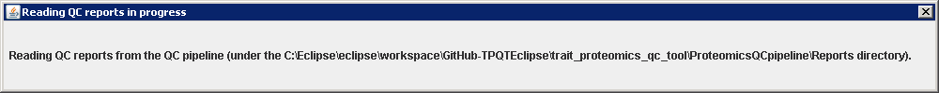
Figure 1: Operation in progress dialogue

Main user interface: The main user interface is divided into three panels – 1) Control panel, 2) Reports panel and 3) TIC panel. The control panel provides options to sort and zoom reports displayed in the report panel. The report panel displays available QC reports along with the values of calculated QC metrics. The TIC panel displays larger TIC graph corresponding to QC report selection in report panel. The description of these panels and corresponding options is given in Table 5.
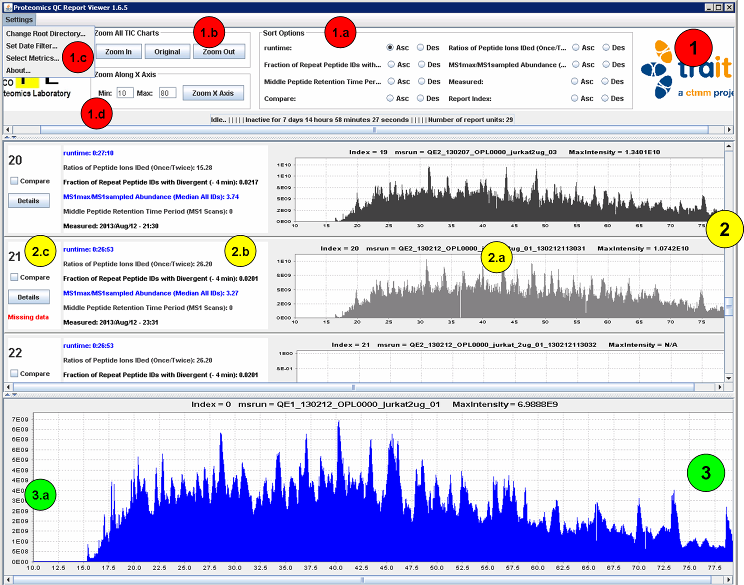
Figure 2: Main user interface of MSQC report viewer

Table 5: Description of options in MSQC report viewer

UI Item | Description
1.a: Sort options | The reports displayed in report panel can be sorted in Ascending and Descending order according to the values selected QC metrics. In addition, sorting according to the selection of report compare check-box and report index is provisioned.
1.b: Zoom All TIC Charts | Zoom In -> Clicking this button will zoom in (expand) all TIC graphs in report panel and TIC panel along X axis (MS Runtime in minutes).  Original -> Clicking this button will show original TIC graphs in report panel and TIC panel  Zoom Out -> Clicking this button will zoom out (shrink) all TIC graphs in report panel and TIC panel along X axis (MS Runtime in minutes).
1.b: Zoom Along X Axis | Zoom X Axis -> Clicking this button will result in zooming all TIC graphs in report panel and TIC panel – such that Min and Max represent range of X axis in minutes. The default zoom range is 10 – 80 minutes. In case of invalid Min and Max values, an error message is shown as follows:  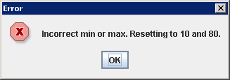
1.c: Settings – Set Root Directory… | 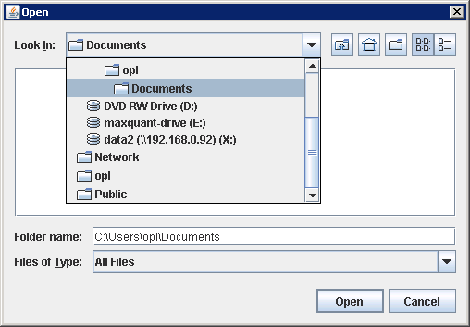  Selecting this option displays directory chooser to select QC reports from. On selecting directory that do not contain QC reports, following error message is displayed:  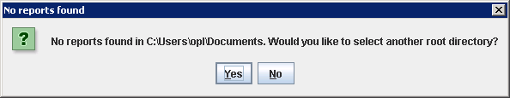  If the new root directory contains QC reports, existing reports will be removed and reports from the new root directory will be shown in the report viewer.
1.c: Settings – Set Date Filter… | Selecting this option displays date filter form to choose From and Till date – for limiting number of reports to be shown in the report panel. On selecting appropriate dates, the report viewer displays reports generated during the period specified by From and Till dates.  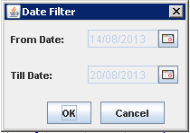  In case the chosen From Date is after Till Date, following error message is displayed.  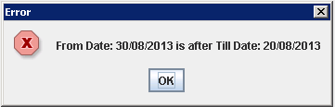
1.c: Settings – Select Metrics | Selecting this option opens the following Drag n Drop interface for selecting the metrics to be shown along with every report. At present, maximum six metrics can be selected.  On selection of desired metrics, the report viewer displays reports with the values of selected metrics. The sort options are updated to newly selected metrics.  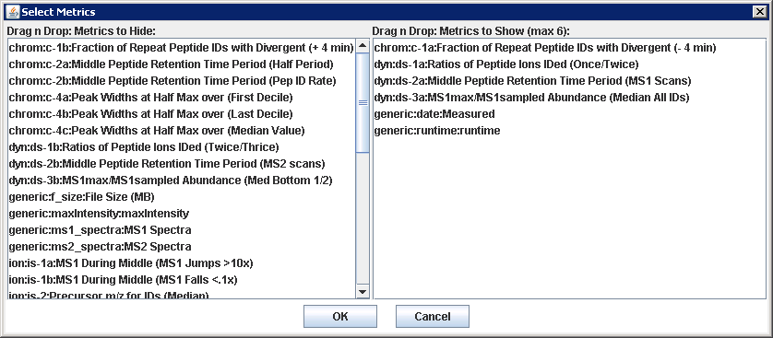
1.c: Settings – About… | Selecting this option opens About… page displaying following frame:  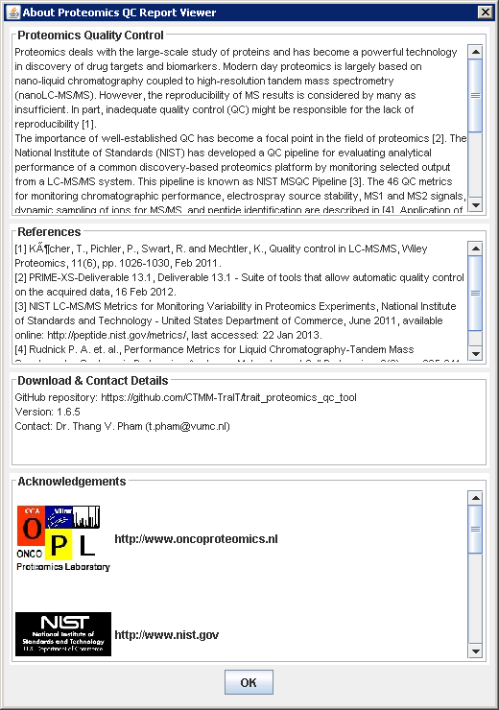
1.d: Pipeline status message | This area displays current QC pipeline status as available from the pipeline log file. The log file is checked periodically for status update. The status message consists of the following:  1) Pipeline state: a) Idle or b) Processing RAW file ….  2) Time elapsed: a) Active since … or b) Inactive for…  3) Number of reports in the viewer.
2.a: Embedded TIC graph | This area shows TIC graph based on values of TIC matrix generated by QC pipeline.
2.b: QC metrics values | This area shows values of selected QC metrics as obtained from QC report. In case of missing metrics values, N/A value is shown.
2.c: Details button | Selecting this option will open a new frame displaying values of all QC metrics corresponding to associated report.  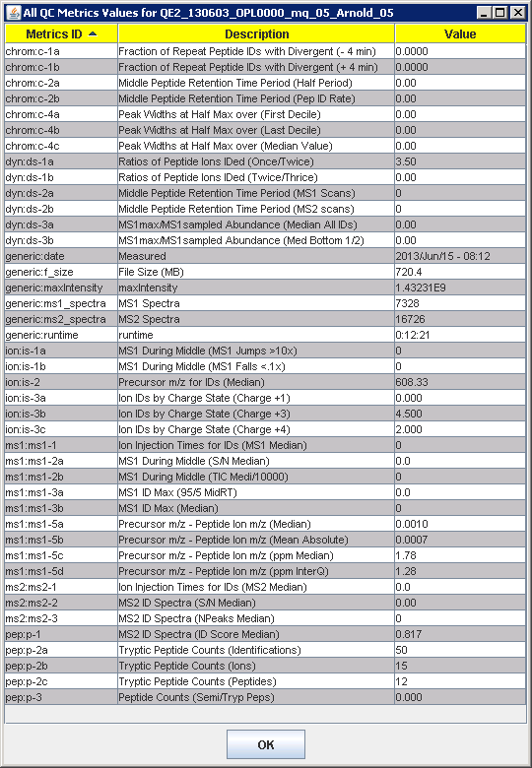
2.c: Compare checkbox | Selecting the checkbox corresponding to a particular QC report means the report is to be compared with other reports which also have corresponding checkbox selected. The checkbox selection should be followed by the use of Sort option – according to Compare flag.
2.c: Missing data | The report displays status ‘Missing data’ in following cases:  - Missing one or all data files (metrics.json, *_ticmatrix.csv)  - Missing metrics values.  - Missing TIC graph.

References
- Köcher, T., Pichler, P., Swart, R. and Mechtler, K., Quality control in LC-MS/MS, Wiley Proteomics, 11(6), pp. 1026-1030, Feb 2011.
- PRIME-XS-Deliverable 13.1, Deliverable 13.1 - Suite of tools that allow automatic quality control on the acquired data, 16 Feb 2012.
- NIST LC-MS/MS Metrics for Monitoring Variability in Proteomics Experiments, National Institute of Standards and Technology - United States Department of Commerce, June 2011, available online: http://peptide.nist.gov/metrics/, last accessed: 22 Jan 2013.
- Rudnick P. A. et. al., Performance Metrics for Liquid Chromatography-Tandem Mass Spectrometry Systems in Proteomics Analyses, Molecular and Cell Proteomics, 9(2), pp. 225–241, Feb 2010.
- CTMM Translational Research IT (TraIT) project website: http://www.ctmm.nl/pro1/general/start.asp?i=1&j=0&k=0&p=0&itemid=330

Appendix 1 – QC-Full Performance Metrics – Description, Significance and Examples

Metric | Units | Optimal | Purpose/use/significance | Description | Yeast1 | Example1 | Example2
generic:date:Measured | Date-Time | - | Date-Time at which pipeline processing (begin??/finished??) | Date-Time at which pipeline processing (begin??/finished??)
generic:runtime:runtime | Time | Lower is better | Time taken for the QC-pipeline processing | Time taken for the QC-pipeline processing
generic:f_size:File Size (MB) | MB | - | RAW data file size | RAW data file size
generic:ms1_spectra:MS1 Spectra | Count | Lower is better | Fewer MS1 scans indicates more sampling | Number of MS1 scans | 5329
generic:ms2_spectra:MS2 Spectra | Count | Higher is better | More MS2 scans indicates more sampling | Number of MS2 scans | 16766
Ion:is-3a:Ion IDs by Charge State (Charge +1) | Ratio | Lower is better | High ratios of 1+/2+ peptides may indicate inefficient ionization | Number of 1+ peptides over 2+ peptides | 0.004 | 0.000 | 0.000
ion:is-3b:Ion IDs by Charge State (Charge +3) | Ratio | Lower is better | Higher ratios of 3+/2+ peptides may preferentially favor longer peptides | Number of 3+ peptides over 2+ peptides | 0.479 | 6.000 | 3.714
ion:is-3c:Ion IDs by Charge State (Charge +4) | Ratio | Lower is better | Higher ratios of 4+/2+ peptides may preferentially favor longer peptides | Number of 4+ peptides over 2+ peptides | 0.088 | 8.000 | 3.143
ion:is-2:Precursor m/z for IDs (Median) | Th (Thmoson) | Lower is better | Higher median m/z can correlate with inefficient or partial ionization | Median m/z value for all identified peptides (unique ions) | 612.59 | 751.92 | 674.05
ion:is-1b:MS1 During Middle (MS1 Falls <.1x) | Count | Lower is better | Flags ESI instability | Number of times where MS1 signal greatly increased between adjacent scans more than 10-fold (electrospray instability) | MS1 Falls < 10x  0 | 0 | 0
ion:is-1a:MS1 During Middle (MS1 Jumps >10x) | Count | Lower is better | Flags ESI instability | Number of times where MS1 signal greatly decreased between adjacent scans more than 10-fold (electrospray instability) | 0 | 0 | 0
dyn:ds-2b:Middle Peptide Retention Time Period (MS2 scans) | Min |  |  |  | 4840 | 10956 | 3378
dyn:ds-2a:Middle Peptide Retention Time Period (MS1 Scans) | Min |  |  |  | 633 | 0 | 0
dyn:ds-1b:Ratios of Peptide Ions IDed (Twice/Thrice) | Ratio | Higher is better | Estimates oversampling | Ratio of peptides identified by 2 spectra divided by number identified by 3 spectra | 5.71 | 0.00 | 6.00
dyn:ds-1a:Ratios of Peptide Ions IDed (Once/Twice) | Ratio | Higher is better | Estimates oversampling | Ratio of peptides identified by 1 spectrum divided by number identified by 2 spectra | 28.24 | 28.00 | 4.83
dyn:ds-3a:MS1max/MS1sampled Abundance (Median All IDs) | Ratio | Lower is better | Estimates position on peak where sampled for peptides of all abundances | Ratio of MS1 maximum to MS1 value at sampling for median decile of peptides by MS1 maximum intensity (1 = sampled at peak maxima) | 1.78 | 2.19 | 2.73
dyn:ds-3b:MS1max/MS1sampled Abundance (Med Bottom 1/2) | Ratio | Lower is better | Estimates position on peak where sampled for least abundant 50% of peptides | Ratio of MS1 maximum to MS1 value at sampling for bottom 50% of peptides by MS1 maximum intensity (1 = sampled at peak maxima) | 1.43 | 0.00 | 0.00
chrom:c-4a:Peak Widths at Half Max over (First Decile) | s | Lower is better | Estimates peak widths at the beginning of the gradient | Median peak width for identified peptides in last RT decile (late) | 16.08 | 0.00 | 0.00
chrom:c-4b:Peak Widths at Half Max over (Last Decile) | s | Lower is better | Estimates peak widths at the end of the gradient | Median peak width for identified peptides in first RT decile (early) | 21.3 | 0.00 | 0.00
chrom:c-4c:Peak Widths at Half Max over (Median Value) | s | Lower is better | Estimates peak widths in the middle of the gradient | Median peak width for identified peptides in median RT decile (middle) | 20.34 | 0.00 | 0.00
chrom:c-1b:Fraction of Repeat Peptide IDs with Divergent (+ 4 min) | Fraction | Lower is better | Estimates very late peak broadening | Fraction of all peptides identified at least 4 min later than max MS1 for ID | 0.0051 | 0.0000 | 0.00
chrom:c-1a:Fraction of Repeat Peptide IDs with Divergent (- 4 min) | Fraction | Lower is better | Estimates very early peak broadening | Fraction of all peptides identified at least 4 min earlier than max MS1 for ID | 0.0027 | 0.0313 | 0.1809
chrom:c-2b:Middle Peptide Retention Time Period (Pep ID Rate) | Peps/min | Higher is better | Higher rates indicate efficient sampling and identification | Rate of peptide identification during … | 46.62 | 0.50 | 2.56
chrom:c-2a:Middle Peptide Retention Time Period (Half Period) | Min | Higher is better | Longer times indicate better chromatographic separation | Time period over which 50% of peptides were identified | 32.62 | 24.12 | 13.26
pep:p-2c:Tryptic Peptide Counts (Peptides) | Count | Higher is better | A good overall performance measure | Number of tryptic peptide ions identified; ions differing by charge state and/or modification state are counted separately | 3023 | 24 | 66
pep:p-2b:Tryptic Peptide Counts (Ions) | Count | Higher is better | A good overall performance measure | Number of tryptic peptide ions identified; ions differing by charge state and/or modification state are counted separately | 3518 | 31 | 71
pep:p-2a:Tryptic Peptide Counts (Identifications) | Count | Higher is better | Total identifications correlate with high levels of peptide signals, performance | Number of MS2 spectra identifying tryptic peptide ions (total “spectral counts”) | 3704 | 32 | 90
pep:p-1:MS2 ID Spectra (ID Score Median) | fval (float??) | Higher is better | Higher scores correlate with higher S/N and frequency of identification | Median peptide identification score for all peptides; higher scores generally correlate with increased MS2 S/N | 0.55 | 0.895 | 0.793
pep:p-3:Peptide Counts (Semi/Tryp Peps) | Ratio | - | Indicates prevalence of semitryptic peptides in sample; increasing ratios may indicate changes in sample or in source | Ratio of semi/fully tryptic peptide IDs | 0.006 | 0.000 | 0.030
ms2:ms2-1:Ion Injection Times for IDs (MS2 Median) | ms | Lower is better |  | MS2 ion injection time | 100 | 80.0 | 80.0
ms2:ms2-2:MS2 ID Spectra (S/N Median) | Ratio | Higher is better | Higher S/N correlates with increased frequency of peptide identification | Median S/N (ratio of maximum to median peak height) for identified MS2 spectra | 79.33 | 53.36 | 26.95
ms2:ms2-3:MS2 ID Spectra (NPeaks Median) | Count | Higher is better | Higher peak counts can correlate with more signal | Median number of peaks in an MS2 scan | 427 | 1056 | 112
ms1:ms1-2b:MS1 During Middle (TIC Medi/10000) | Counts/ 10000 | Higher is better | Estimates the total absolute signal for peptides (may vary significantly between instruments) | Median TIC value for identified peptides over same time period as used for MS1-2A | TIC/Medi /1000  164104 | 0 | 0
ms1:ms1-3a:MS1 ID Max (95/5 MidRT) | Ratio | Higher is better | Estimates the dynamic range of the peptide signals | Ratio of 95th over 5th percentile MS1 maximum intensity values for identified peptides (approximates dynamic range of signal) | 34.5 | 139.9 | 3516.0
ms1:ms1-3b:MS1 ID Max (Median) | Counts | Higher is better | Estimates the median MS1 signal for peptides | Median maximum MS1 value for identified peptides | 1202701 | 4.6e+7 | 4.4e+6
ms1:ms1-2a:MS1 During Middle (S/N Median) | None??? | Higher is better | Higher MS1 S/N may correlate with higher signal discrimination | Median signal-to-noise value (ratio of maximum to median peak height) for MS1 spectra up to and including C-2A | 99.3 | 0.0 | 0.0
ms1:ms1-5c:Precursor m/z - Peptide Ion m/z (ppm Median) | ppm | Lower is better | Measures the accuracy of the identifications | Median real value of precursor errors in ppm | -2.02 | 1.19 | -2.73
ms1:ms1-5b:Precursor m/z - Peptide Ion m/z (Mean Absolute) | Th | Lower is better | Measures the accuracy of the identifications | Mean of the absolute precursor errors | 0.0063 | 0.0011 | 0.0132
ms1:ms1-5a:Precursor m/z - Peptide Ion m/z (Median) | Th | Lower is better | Measures the accuracy of the identifications | Median real value of precursor errors | -0.0011 | 1.19 | -0.0019
ms1:ms1-1:Ion Injection Times for IDs (MS1 Median) | ms | Lower is better | Lower times indicate an abundance of ions | MS1 ion injection time | 49 | 1 | 2
ms1:ms1-5d:Precursor m/z - Peptide Ion m/z (ppm InterQ) | ppm | Lower is better | Measures the distribution of the real accuracy measurements | Interquartile distance in ppm of the precursor errors | 3.36 | 3.43 | 4.78

http://peptide.nist.gov/metrics/NISTMSQC_1.0.3_Manual.pdf
QE2_130225_OPL0000_jurkat2ug_02.RAW
QE2_130306_OPL1013_8x3_CRC_TiOx_rerun_HCT116_2.RAW

